Jacob Smith 3/11/2020 11:00 AM: This notebook will contain the work I am doing on the C2 tactors for Dr. Vimal’s experiment at the Graybiel Laboratory Brandeis University. This is the wiring diagram for the c2 tactors, to go along with this code.

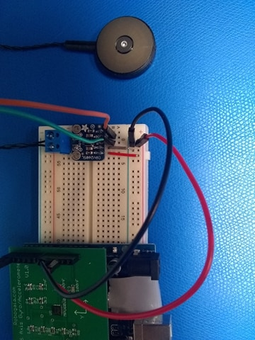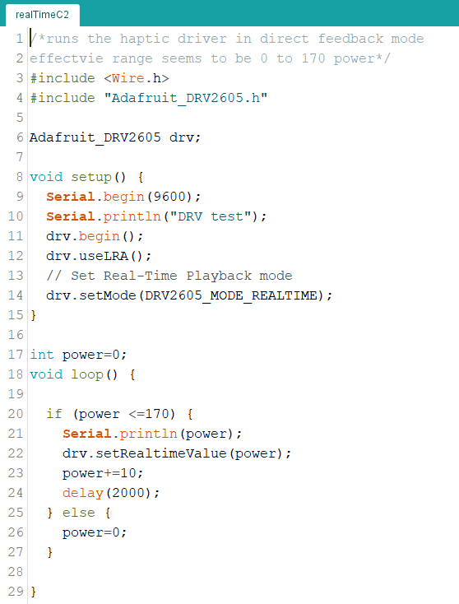

<https://www.youtube.com/watch?v=XWQsqPQOW-U>

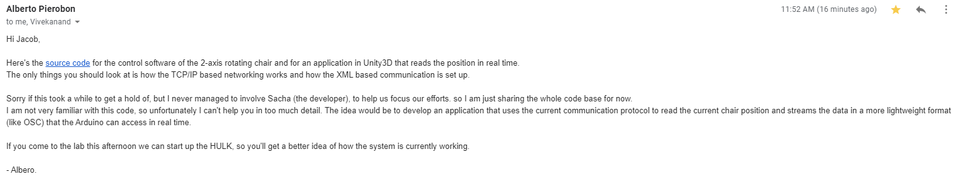

<https://drive.google.com/drive/folders/1t6LkPKo_KGxpAeBke-ozXG1Z_jcuZ24s> (google drive folder)

Can’t get multiplexer working, but made new apparatus base